EC2 INSTANCE CHALLENGES DOCUMENT
- Launch one EC2 instance using Amazon Linux 2.
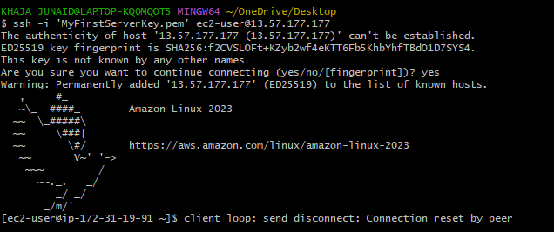
2. Install Docker.
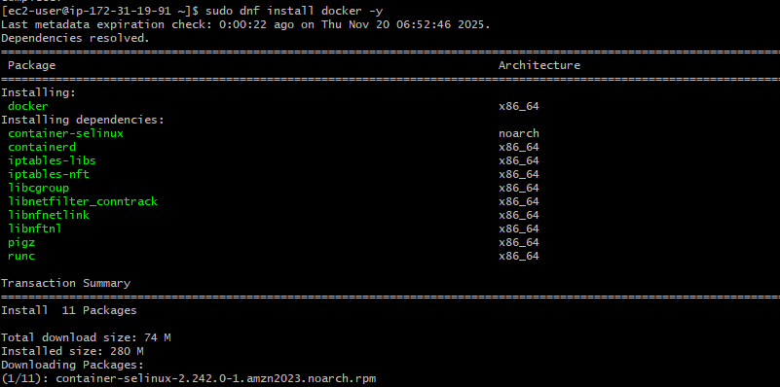
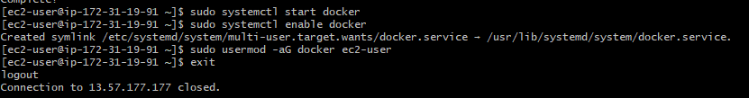

Docker info:
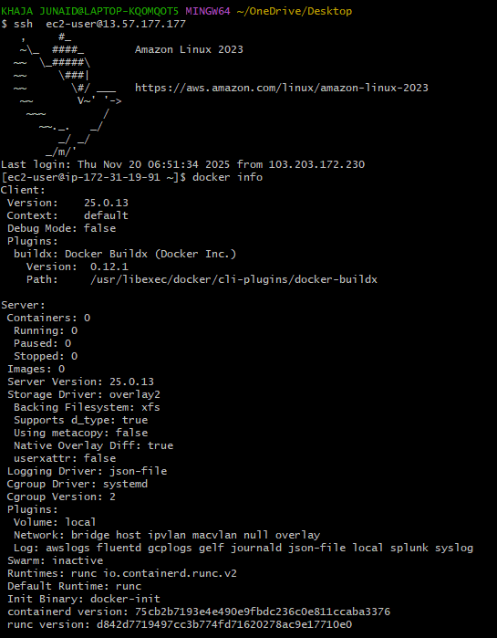

Docker run hello-world:
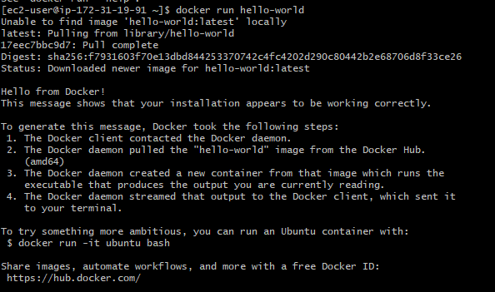
3. Install Jenkins.
sudo dnf update -y
sudo dnf install java-17-amazon-corretto -y
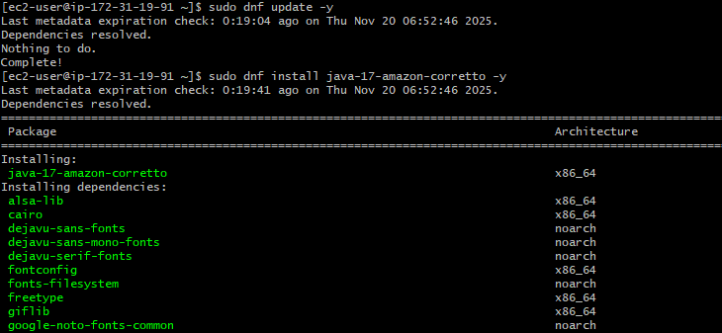
sudo dnf install wget -y
wget -O /etc/yum.repos.d/jenkins.repo \
https://pkg.jenkins.io/redhat-stable/jenkins.repo

sudo rpm --import https://pkg.jenkins.io/redhat-stable/jenkins.io-2023.key
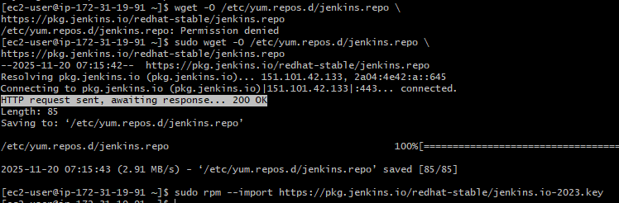
sudo dnf install jenkins -y
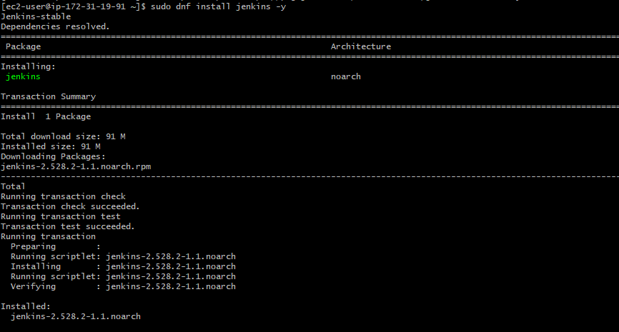
sudo systemctl start jenkins
sudo systemctl enable Jenkins

4.Install Apache.
sudo dnf update -y
sudo dnf install httpd -y
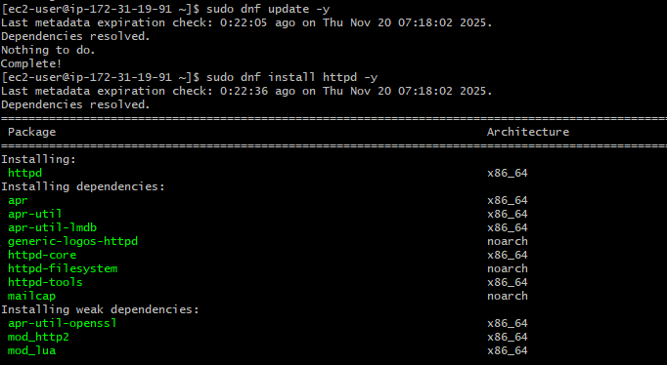
sudo systemctl start httpd
sudo systemctl enable httpd
sudo systemctl status httpd
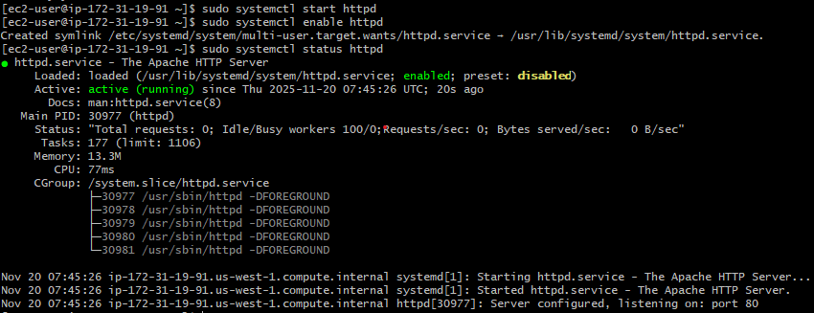
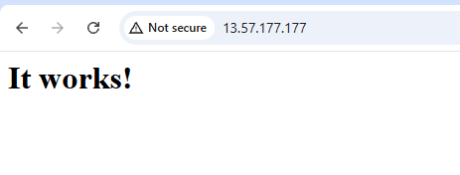
- Install Nginx.

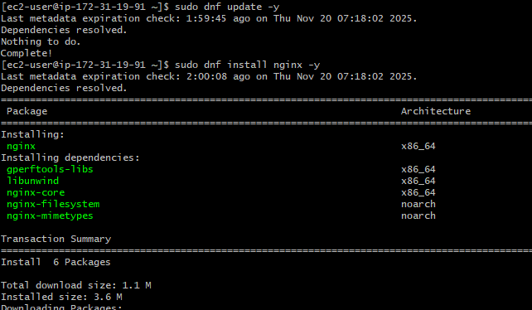
sudo systemctl start nginx
sudo systemctl enable nginx
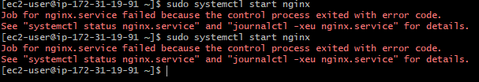

Change port no 80 to 81 for nginx.
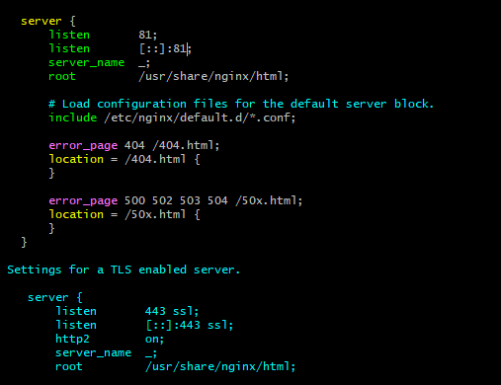
Edit inbound rules add 82 port for nginx
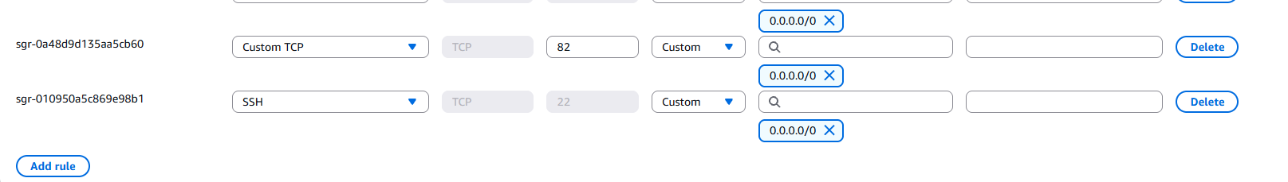
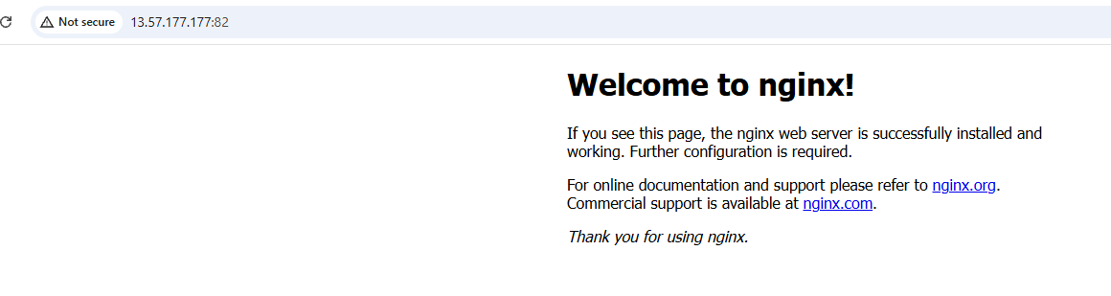
6.Install Apache Tomcat.
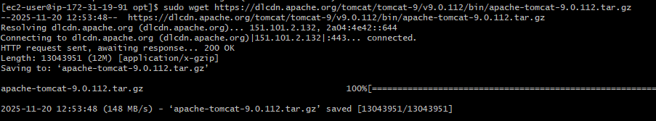

Port no 8080 is not available for tomcat
